Teaching notes

This is a carousel activity for GCSE students. It could be used for teaching ‘Germany, 1890-1945: Democracy and dictatorship’ to help students understand the effects of Nazi social policy on different groups.

Materials included

- Student table to record ideas (p.2).
- Task cards for each of the four areas (pp.3-4).
- Evidence packs for each of the four areas (pp.5-12), cut into individual sources.

The activity

- Using the table students initially record what they might expect Nazi policy to be on four areas; youth, women, family and education.

- Working in small groups (three would work well for discussion) students then consider each of the areas again, this time in the light of a pack of primary evidence for each area. Using the task cards they are prompted to discuss a number of questions which should help them to analyse the sources. Their findings can once again be recorded on the table.

- The evidence packs are rotated to allow each group to consider each area.

Extension/differentiation ideas

This activity could be differentiated in a number of ways. Students might be organised into mixed ability groups and assigned different roles, perhaps one to record, one to read out, one to look up unknown words or ideas. Or, within their groups, different students could be assigned different sources according to the complexity of the text.

Very able students might be asked to consider the limitations of individual sources or even of the sources as a set – what can’t they know from the evidence they have been provided with on this occasion and how might they go about learning more?

What can primary evidence tell us about Nazi social policy?
Task 1: Record what you expect to find out about Nazi social policy in each of the areas.
Youth groups | The role of women
What do you expect to find? | What do you expect to find?
What does the evidence suggest? | What does the evidence suggest?
The family | Education
What do you expect to find? | What do you expect to find?
What does the evidence suggest? | What does the evidence suggest?
Task 2: Use the evidence packs to record what primary sources tell you about Nazi social policy. You could write down key words, quotes or ideas which you can infer (work out) from the sources.

Task card: Youth groups

Items in the evidence pack:

- a German woman’s account of her time in the BDM (the League of German Maidens)
- a timetable from a labour camp for young adults
- some statistics on Hitler Youth membership
- a photograph of Hitler with three children. The image was included within a leaflet distributed to German citizens by the Nazi government.

Questions to consider:

  - What was the purpose of the youth groups?
  - What kind of activities were there?
  - What evidence is there that young people wanted to join and enjoyed being part of the youth groups?
  - What evidence is there that there was some resistance to the youth groups?
  - Do you think the youth groups achieved their aims?

Task card: The role of women

Items in the evidence pack:

- an extract from a speech made by Goebbels, minister for propaganda, in Munich, 1934
- extracts from a speech made by Gertud Scholtz-Klink, leader of the National Socialist Women's League, in January 1936
- a description of the ‘Cross of Honour for the German Mother’.

Questions to consider:

  - What did the Nazis expect of women?
  - What did they expect of men?
  - Does anything in Gerturd Scholtz-Klink’s speech surprise you?

Task card: The family

Items in the evidence pack:

- a list of policies introduced by the Nazis
- a quote from Josef Goebbels, Nazi propaganda minister, 1929
- a photograph of a woman receiving an honorary cross for mothering a large family

Questions to consider:

- What was the Nazis’ view of the perfect family?
- How did their policies hope to achieve this?
- What kind of emotions do you think the posters were designed to bring out?

Task card: Nazi education

Items in the evidence pack:

- the History curriculum as recommended by the Nazis
- a timetable for a girls’ school in Nazi Germany
- a question from a Nazi maths textbook
- a speech made by Hitler in 1939
- an account by a British teacher in Germany.

Questions to consider:

- What were the most important aims of Nazi education?
- Do you think the timetable from the girls’ school was different to timetables at boys’ schools?
- What do you think it was like to be a teacher in Nazi schools?
- What effect do you think Nazi education had on German youth?

Evidence pack: Youth groups

- A German woman’s account of her time in the BDM (the League of German Maidens)

‘... girls of my age had to attend evening classes twice weekly. We had to be present at every public meeting and at youth rallies and sports. The weekends were crammed full with outings, camping, and marches when we carried heavy packs on our backs. It was all fun in a way, and we certainly got plenty of exercise, but it had a bad effect on our school reports. There was hardly ever any time for homework.

The evening classes were conducted by young girls, usually hardly older than we were ourselves. These young BDM leaders taught us songs and tried desperately to maintain a certain amount of discipline without ever really succeeding … We were marched up and down as though we were soldiers … we were of course lectured on a lot of Nazi ideology, and most of this went over our heads … we were told from a very early age to prepare for motherhood, as the mother in the eyes of our beloved leader … was the most important person in the nation. We were Germany’s hope and Germany’s future.’

As reproduced in Nazi Culture: Intellectual, Cultural, and Social Life in the Third Reich, p.277, University of Wisconsin Press, 2003.

- A timetable from a labour camp for young adults

6.00 | Get up (5.00 in summer) | 3.00 – 4.00 | Rest
6.05 – 6.20 | Exercises | 4.00 – 5.00 | Sport
6.20 – 6.40 | Washing; bed making | 5.00 – 6.00 | Political studies
6.40 – 6.55 | Breakfast | 6.00 – 7.00 | Allocation of jobs to be done the next day
7.00 – 7.30 | Flag parade; speech by camp leader | 7.00 – 8.00 | Supper
7.30 – 2.30 | March to work; six hours’ farm work | 8.00 – 9.00 | Songs and dancing; speeches
2.30 – 3.00 | Midday meal | 10.00 | Lights out

- Some statistics on Hitler Youth membership

In 1932 | - | 107,956 members
In 1934 | - | 3,500,000 members
From 1936 onwards | - | Over 6 million members

- A photograph of Hitler with three children. The image was included within a leaflet distributed to German citizens by the Nazi government.

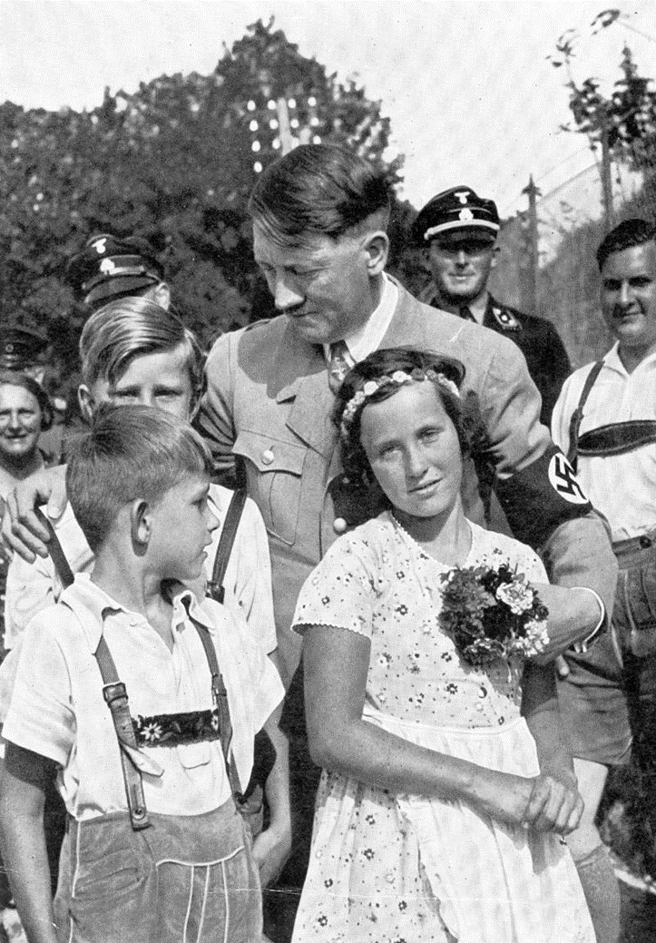

Image credit:
Part of the Charles Overstreet Collection, Flora Public Library.
Digitized and made available by IMLS Digital Collections and Content on Flickr.
Unrestricted access; use with attribution.

Evidence pack: the role of women

- An extract from a speech made by Goebbels, minister for propaganda, in Munich, 1934
‘German women, German men!
It is a happy accident that my first speech since taking charge of the Ministry of Public Enlightenment and Propaganda is to German women. Although I agree with Treitschke that men make history, I do not forget that women raise boys to manhood. You know that the National Socialist movement is the only party that keeps women out of daily politics. This arouses bitter criticism and hostility, all of it very unjustified. We have kept women out of the parliamentary-democratic intrigues of the past fourteen years in Germany not because we do not respect them, but because we respect them too much. We do not see the woman as inferior, but rather as having a different mission, a different value, than that of the man. Therefore we believed that the German woman, who more than any other in the world is a woman in the best sense of the word, should use her strength and abilities in other areas than the man.’
Source: http://www.calvin.edu/academic/cas/gpa/goeb55.htm

- Extracts from a speech made by Gertud Scholtz-Klink, leader of the National Socialist Women's League, in January 1936

‘The woman, besides caring for her own children, should first care for those who need her help as mothers of the nation.’

‘Women, I wish to try briefly to make clear what the deepest calling we women have is: motherhood. In the bad fourteen years between 1918 and 1933, motherhood was often robbed of its deepest meaning and reduced to something superficial, something that was even held in contempt.’

‘Not only those women with children will become mothers of the nation, but rather each German woman and each girl will become one of the Führer’s little helpers wherever she is, be it in the labour service, in a factory, at a university or in a hospital, at home or on the high seas.’

Source: http://www.calvin.edu/academic/cas/gpa/scholtz-klink2.htm

- A description of the ‘Cross of Honour for the German Mother’

Hitler was very concerned with increasing the birth-rate in Germany which had declined after the First World War. The Nazi regime organised a propaganda campaign which aimed to encourage women to have as many children as possible. They were rewarded in this with a medal according to how many children they had produced. Should a woman be particularly successful in this respect there were other rewards too. For example, Hitler would be the godfather of any tenth child in a family.

The medal itself was a striking item. It featured a central swastika framed by the correct colour of metal with the words ‘Der Deutschen Mutter’ – the German Mother. This was attached to a blue and white striped ribbon. Many women cherished these items.

The medals were awarded as follows:

Bronze medal | - | For having four or five children
Silver medal | - | For having six or seven children
Gold medal | - | For having eight or more children

For an image see of the medal see: en.wikipedia.org/wiki/File:Deutsches_Reich_Mother%27s_Cross_of_Honour.jpg

Evidence pack: the family

- A list of policies introduced by the Nazis.

- Couples were given marriage loans and birth grants – money for getting married and starting a family.
- Abortions were restricted.
- Childless couples were taxed more highly.
- Healthcare, especially for mothers, was improved.
- Women were banned from working in the civil service and banned from being judges, doctors or lawyers.

- A quote from Josef Goebbels, Nazi propaganda minister, 1929.

‘The mission of women is to be beautiful and bring children into the world … The female bird pretties herself for her mate and hatches eggs for him. In exchange, the mate takes care of gathering the food, and stands guard and wards off the enemy.’

- A photograph of a woman receiving an honorary cross for mothering a large family.

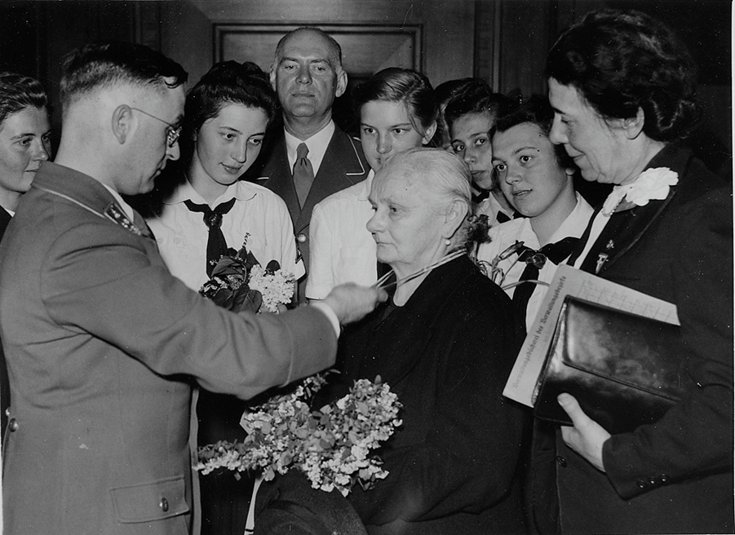

Image credit:
This photograph is believed to have been taken in Germany on Mother’s Day in 1943. It is now part of a collection from the National Archives of Norway on Flickr.

Evidence pack: education

- The History curriculum recommended by the Nazis

Weeks | Subject | Relations to Jews
1-4 | Pre-war Germany  The class war  Profits, strikes | The Jew at large!
5-8 | From agrarian to industrial state  Colonies | The peasant in the claws of the Jews
9-12 | Conspiracy against Germany | The Jew reigns. War plots
13-16 | German struggle, German want  Blockade! Starvation! | The Jew becomes prosperous!  Profit from German want
17-20 | The stab in the back. Collapse. | Jews as leaders of the November insurrection
21-24 | Germany’s Golgotha  Versailles | Jews enter Germany from the east.  The Jew’s triumph
25-28 | Adolf Hitler  The Nazis | The Jew’s foe!
29-32 | Enslavement of Germany | The Jew profits by Germany’s misfortunes.
33-36 | Nazis at grips with crime and the underworld | Jewish instigators of murder  The Jewish press
37-40 | Germany’s youth at the helm!  The victory of faith | The last fight against the Jew

- A timetable for a girls’ school in Nazi Germany

8.00 | German (every day)
8.50 | Geography, History or singing (alternate days)
9.40 | Race studies and ideology (every day)
10.25 | Recess, sports and special announcements (every day)
11.00 | Domestic science or maths (every day)
12.10 | Eugenics or health biology (alternate days)
1.00 – 6.00 | Sport
Evenings | Sex education, ideology or domestic science (one evening each)

- A question from a Nazi maths textbook

A bomber aircraft on take off carries 144 bombs, each weighing ten kilos. The aircraft bombs a town full of Jews. On take off with all bombs on board and a fuel tank containing 1000 kilos of fuel, the aircraft weighs about 8 tons. When it returns from its victorious mission, there are still 230 kilos of fuel left. What is the weight of the aircraft when empty?

- A speech made by Hitler in 1939

In my great educative work I am beginning with the young. We older ones are used up … We are rotten to the marrow. But my magnificent youngsters! Are there finer ones in the world? With them I can make a new world.
My teaching is hard. Weakness has to be knocked out of them … A violently active, dominating, intrepid, brutal youth – that is what I am after … It must be indifferent to pain. There must be no weakness or tenderness in it …
I will have no intellectual training. Knowledge is ruin to my young men … One thing they must learn, self-command!

- An account by a British teacher in Germany

Nazis were sent to schools, where they walked into the classes and cross-examined the teacher in front of his pupils. If they thought it necessary they arrested him at once.

