Key
Union states
Border states
Confederate states
Version 1
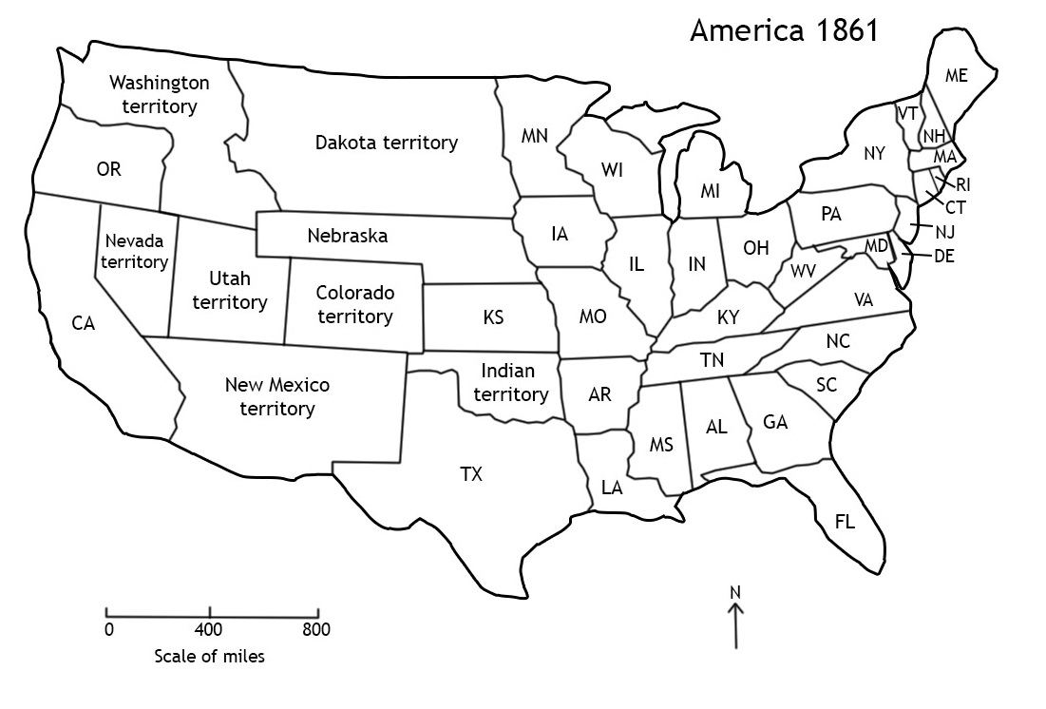
a) W_____________
b) H_____________
F_________________

c) R_______________
d) N _____ T____________
R ____________

e) F________ S__________

f) M________________ C_________________

Map version 1 tasks

- Colour your map to show the different sides in the American Civil War. Use the chart below to guide you. The letters in bold in each state’s name will help you match it to the correct state on your map. Use one colour for the Union states, a second colour for the Border states, and a third for the Confederate states. Remember, though, that the Border states fought on the same side as the Union states. Complete the key in the top right corner of the map to show which colours you have used for the three groups of states.

Union (Northern) states | Border states (these were slave states that did not leave the Union) | Confederate (Southern) states
California, Connecticut, Illinois, Iowa, Indiana, Kansas, Maine, Massachusetts, Michigan, Minnesota, New Hampshire, Nevada, New Jersey, New York, Ohio, Oregon, Pennsylvania, Rhode Island, Vermont, Wisconsin | Delaware, Kentucky, Maryland, Missouri, West Virginia | Alabama, Arkansas, Florida, Georgia, Louisiana, Mississippi, North Carolina, South Carolina, Tennessee, Texas, Virginia

- Fill in the boxes on the right hand side of the map using the following clues to help you:

- the capital city of the Union states
- where John Brown tried to capture a store of weapons
- the capital city of the Confederate states
- the name of the slave revolt which happened here in 1831
- where the first shots of the American Civil War were fired
- this agreement in 1820 allowed slavery in this state and to the south of it, but not any further north.
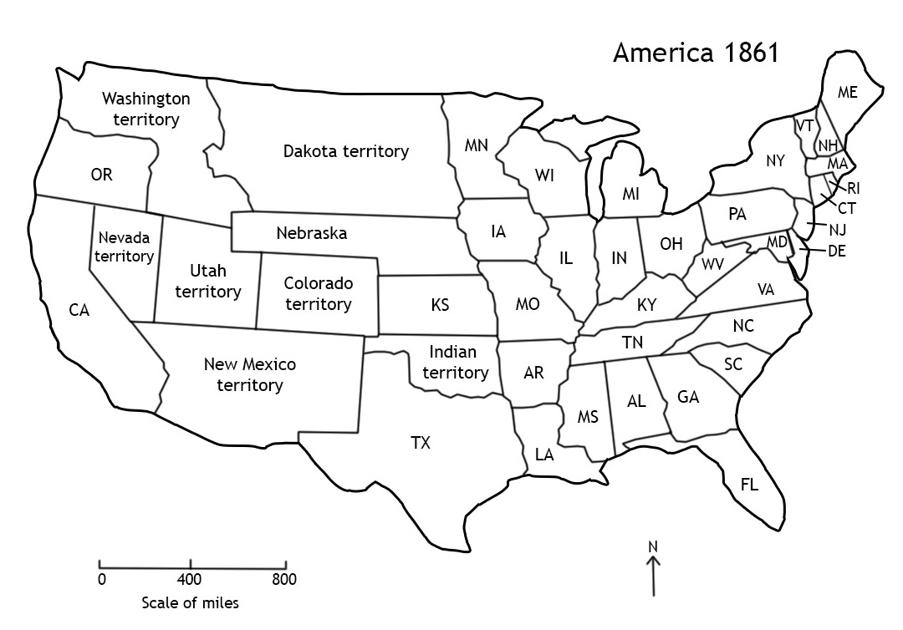
Version 2
a
b
c
d
e
f
Map version 2 tasks

- Colour your map to show the different sides in the American Civil War. Use the chart below to help. The initials on the map will help you identify the states but you may also need an atlas or map that shows the American states to help you. Use one colour for the Union states, a second colour for the Border states, and a third colour for the Confederate states. Remember, though, that the Border states fought on the same side as the Union states. Add a key to the map to show which colours you have used for the three groups of states.

Union states | Border states (these were slave states that did not secede from the Union | Confederate states
California, Connecticut, Illinois, Iowa, Indiana, Kansas, Maine, Massachusetts, Michigan, Minnesota, New Hampshire, Nevada, New Jersey, New York, Ohio, Oregon, Pennsylvania, Rhode Island, Vermont, Wisconsin | Delaware, Kentucky, Maryland, Missouri, West Virginia | Alabama, Arkansas, Florida, Georgia, Louisiana, Mississippi, North Carolina, South Carolina, Tennessee, Texas, Virginia

- Fill in the boxes on the right hand side of the map using the following clues to help you:

- the capital city of the Union states
- where John Brown tried to capture a store of weapons
- the capital city of the Confederate states
- the name of the slave revolt which happened here in 1831
- where the first shots of the American Civil War were fired
- this agreement in 1820 allowed slavery in this state and to the south of it but not any further north.
Version 3
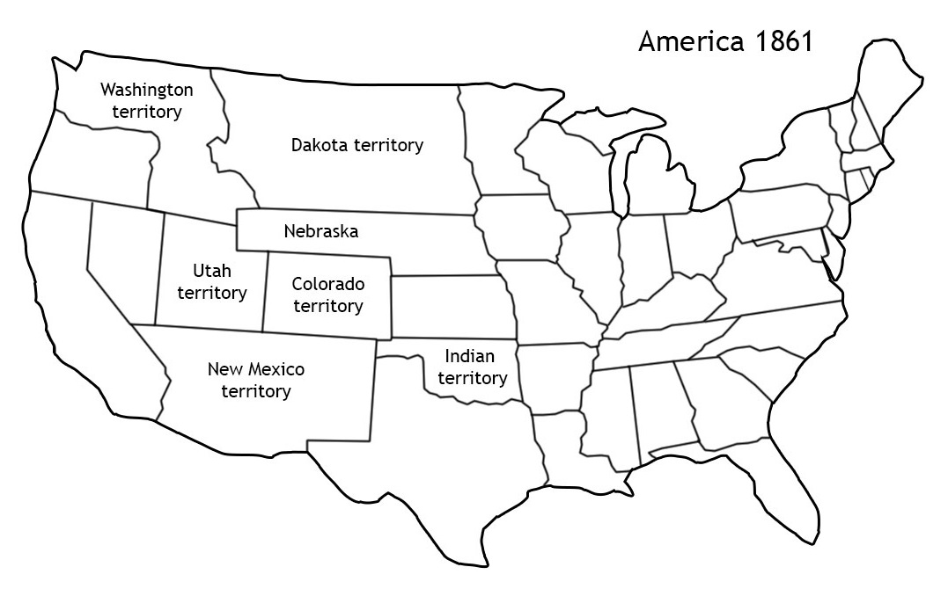

Map version 3 tasks

You will need an atlas or map that shows the American states to complete these tasks.

- Research which states during the American Civil War were:

- Union states
- Confederate states
- Border states (these were slave states that did not secede from the Union)

Colour your map to show the different sides in the American Civil War. Use one colour for the 20 Union states, a second colour for the 11 Confederate states, and a third colour for the 5 Border states. Remember, though, that the Border states fought on the same side as the Union states. Add a key to the map to show which colours you have used for the three groups of states.
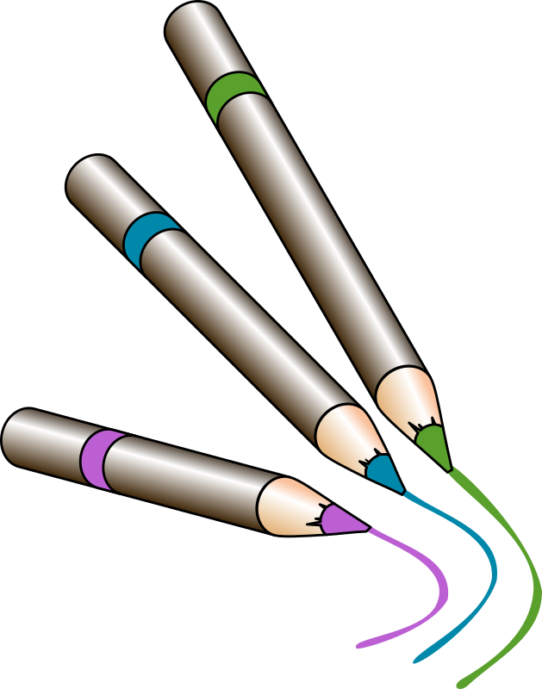
- Research and mark on your map:

- the capital city of the Union states
- where John Brown tried to capture a store of weapons
- the capital city of the Confederate states
- where Nat Turner`s slave revolt took place in 1831
- where the first shots of the American Civil War were fired
- the State where an agreement in 1820 allowed slavery to be introduced
- the line of latitude, south of which slavery was allowed.

Reference map of the United States of America

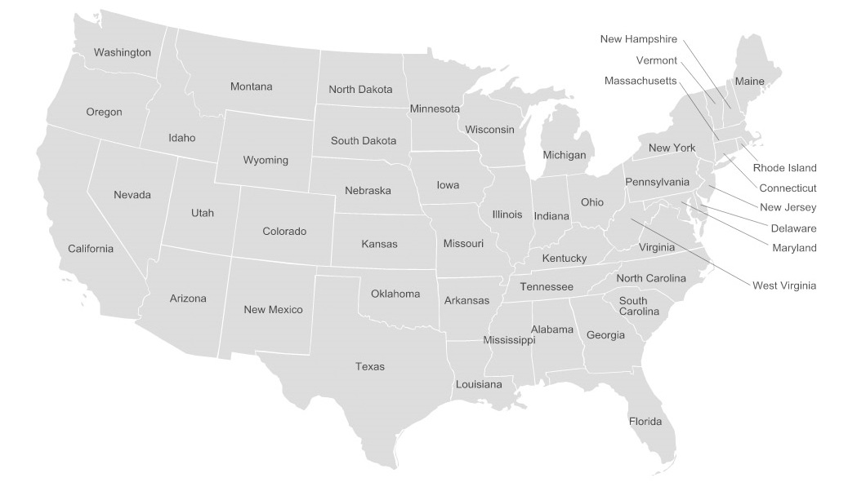
By Gigillo83, original of 70.29.208.129 [GFDL (http://www.gnu.org/copyleft/fdl.html) or CC BY-SA 4.0-3.0-2.5-2.0-1.0 (http://creativecommons.org/licenses/by-sa/4.0-3.0-2.5-2.0-1.0)], via Wikimedia Commons

