Teaching notes

The following activity is designed to cover the Northern Rebellion under Elizabeth I.

Activity one: What makes an effective rebellion?
Students should brainstorm the factors that make for an effective rebellion. These might include size, worthy cause, threat against the monarch – you might chose to add these to a spider diagram on the board.
Possible extension/homework activity: Students could design a ‘recipe for a revolt’. This could build on the first activity of the lesson, with each factor, or ‘ingredient’ being given a quantity and therefore showing how important it was in creating an effective rebellion.

Activity two: Causes and events
This activity is a giant card sort. Students should work in small groups.
Print the statements on pp.2-7. Students are to read them and sort them into ‘causes’ and ‘events’. The activity works best in small groups. Give each group a set of cards and ask them to attach them somewhere visible – this then allows groups to compare their answer. The cards are shown in the correct order on p.8, for checking purposes.

Activity three: Categorising the causes and events
- For each of the causes students should decide whether it is ‘political’, ‘social’ or ‘religious’ and explain whether in their view it would attract support from the people of the North or not.
- For each of the events students should decide who had the momentum − monarch or the rebels − and explain why.

Activity four: Why did the Northern rebellion fail?
Give students a cut out set of the cards that give different reasons for the failure of the rebellion (on p.9). Students are to rank these into a pyramid of importance, with the top box the most important and so on. Students should be able to explain their views.

Activity five:
Go back to the earlier question …
- What makes a good rebellion?
- Was this a good rebellion? Measure it against the students’ criteria from the beginning of the lesson.

They failed to attract support from the Catholic gentry and so abandoned plans to free Mary from Tilbury. The strongholds of the Catholic faith − the northwest in particular − failed to join in.

The rebels claimed that the revolt was designed to protect Mary Queen of Scots whilst in England, as the heir to the English throne.

The Earls of Westmorland and Northumberland gathered a force and marched on Durham, forced the Cathedral to observe Catholic services, then marched south.

On the eve of the rebellion the Duke of Norfolk was summoned to court by Elizabeth after rumours of the plot reached London. Norfolk confessed his involvement and the details.

The Duke of Northumberland felt that he should have played a role in the custody of Mary Queen of Scots. The Duke of Norfolk felt aggrieved at his loss of power in comparison to his position under Mary I.

Elizabeth ordered severe punishments and several hundred were killed. The Puritan Earl of Huntingdon became the new president of the Council of the North. He broke down the links that had kept the northern Earls so powerful, and imposed much more centralised rule.

Without more popular support and with the royal army approaching, Northumberland and Westmorland fled to Scotland. Northumberland was handed over to Elizabeth by the Scots in 1572.

They alleged that Elizabeth ‘maintained a new found religion and heresy, contrary to God’s word’.

Elizabeth was attempting to weaken the hold of families that were viewed as Catholic and potentially disloyal. Previously the great landowners of the north had maintained control. Now Elizabeth looked to put power in the hands of those she trusted, and therefore the families of Northumberland and Westmorland had lost power and status.

The rebels also claimed their revolt, which would bring about the return of the Roman Catholic religion, and therefore Papal control, would protect England from invasion by foreign powers.
Statements for giant card sort (in correct order with headings)
Causes:
Elizabeth was attempting to weaken the hold of families that were viewed as Catholic and potentially disloyal. Previously the great landowners of the north had maintained control. Now Elizabeth looked to put power in the hands of those she trusted, and therefore the families of Northumberland and Westmorland had lost power and status.
The Duke of Northumberland felt that he should have played a role in the custody of Mary Queen of Scots. The Duke of Norfolk felt aggrieved at his loss of power in comparison to his position under Mary I.
They alleged that Elizabeth ‘maintained a new found religion and heresy, contrary to God’s word’.
The rebels also claimed their revolt, which would bring about the return of the Roman Catholic religion, and therefore Papal control, would protect England from invasion by foreign powers.
The rebels claimed that the revolt was designed to protect Mary Queen of Scots whilst in England, as the heir to the English throne.

Events:
On the eve of the rebellion the Duke of Norfolk was summoned to court by Elizabeth after rumours of the plot reached London. Norfolk confessed his involvement and the details.
The Earls of Westmorland and Northumberland gathered a force and marched on Durham, forced the Cathedral to observe Catholic services, then marched south.
They failed to attract support from the Catholic gentry and so abandoned plans to free Mary from Tilbury. The strongholds of the Catholic faith − the northwest in particular − failed to join in.
Without more popular support and with the royal army approaching, Northumberland and Westmorland fled to Scotland. Northumberland was handed over to Elizabeth by the Scots in 1572.
Elizabeth ordered severe punishments and several hundred were killed. The Puritan Earl of Huntingdon became the new president of the Council of the North. He broke down the links that had kept the northern Earls so powerful, and imposed much more centralised rule.
Why did the Northern Rebellion fail?
A. Elizabeth responded effectively to the rebellion and sent troops quickly. | B. The motives were selfish. | C. The people of the North remained loyal to the monarch.
D. Norfolk confessed and therefore the rebellion lacked his support and Elizabeth had prior knowledge of their plans. | E. The rebellion failed to secure powerful support from either a foreign Catholic country, the Pope or Mary Queen of Scots. | F. The rebel plan was flawed – it was only a regional rebellion and was never going to gain enough support.

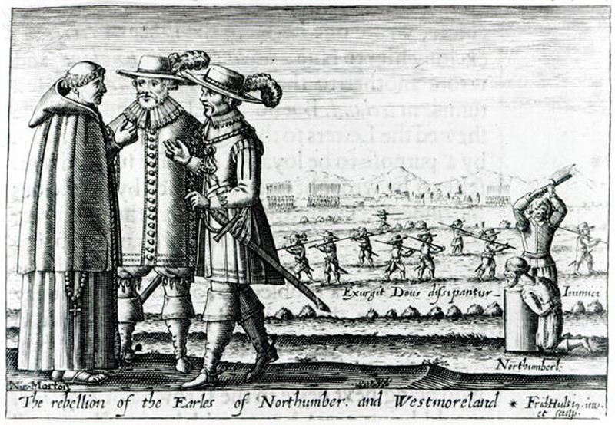
The Rebellion of the Earls of Northumberland and Westmoreland / Credit: Bridgeman Art Library / Universal Images Group / Copyright © Bridgeman Art Library / For Education Use Only. This and millions of other educational images are available through Britannica Image Quest. For a free trial, please visit www.britannica.co.uk/trial

